**Module 6: Critical Thinking**

**Stepwise Refinement Approach**

Ryan Thompson

Colorado State University - Global

CSC 505

Dr. Gonzalez

21 July 2024

**Synopsis**

A Level Computer Science. (2023, June 4) states the stepwise refinement approach is defined as breaking down a problem into a series of steps and substeps . Sometimes this is referred to as a top down approach or design. In this module I made use of the stepwise approach in order to convert a numerical check amount into a text representation. This is done by breaking up the number into smaller pieces. My approach takes the first digit of the number(the base value) and leaves the remainder. At which point the first digit is converted to text and the process is restarted with the remainder. The process continues to loop on itself until there is no remainder. For example, the number 142 will first be broken up into 1 and 42. The numerical 1 turns into a text one. Then the process starts over with the remainder(42), which is split into 4 and 2. Finally, converted into the text “forty two” and added to our “one hundred”. Thus turning into the text representation “One hundred and forty two dollars”. Overall, the stepwise approach is a powerful way to recursively break down a problem into smaller pieces.

**Figures**

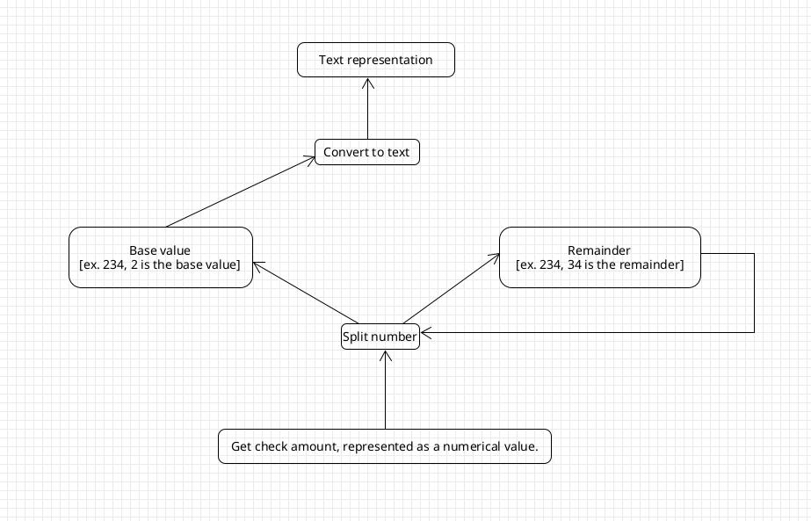

*UML Diagram*

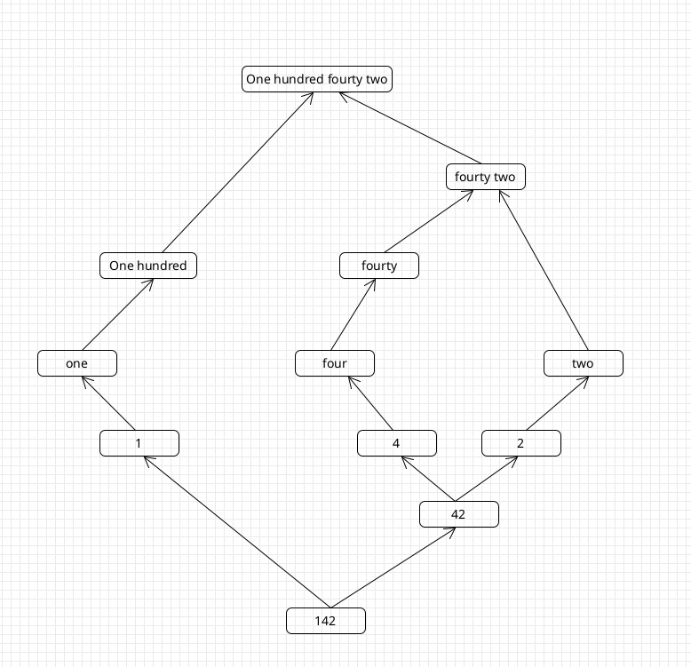

*Example of 142 being converted into its text representation*

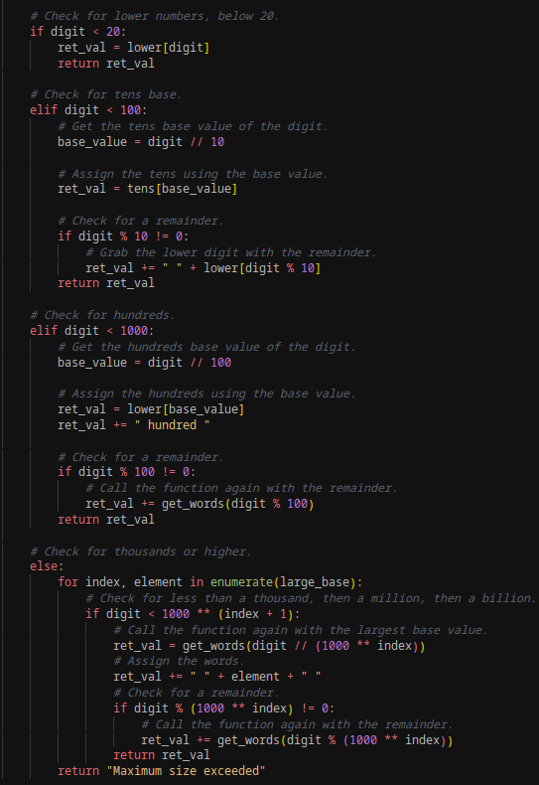

*Approach for splitting up the original numerical value*

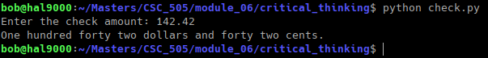

*Program Output*

**References**

Stepwise refinement. A Level Computer Science. (2023, June 4). https://learnlearn.uk/alevelcs/stepwise-refinement/#google_vignette

Stepwise refinement. (n.d.). https://www.cs.odu.edu/~zeil/cs333/website-f11/Lectures/stepwise/page/stepwise.html